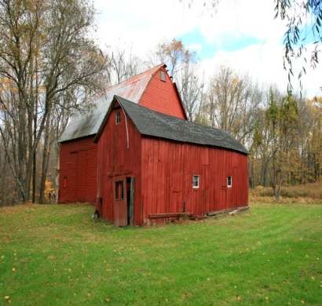
TOWN OF HALLIE ANNUAL MEETING
TUESDAY, APRIL 21, 2026
6:30 PM
TOWN OFFICE
13034 30TH AVE, CHIPPEWA FALLS, WI.

TOWN OF HALLIE ANNUAL MEETING OF THE ELECTORS
- Meeting Called to order per ss 60.11
- Annual Fiscal Report for Town
- Annual Department Reports
A) Fire/EMS
B) Roads
C) Clerk Treasurer
4) Any Business from the electors
5) Set 2027 Annual Meeting Date
6) Adjournment

